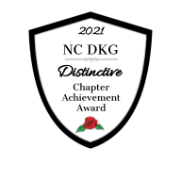
Mission: The Delta Kappa Gamma Society International promotes professional and personal growth of women educators and excellence in education.

ΔΚΓ

Omicron News

The Delta Kappa Gamma Society International
NC DKG – North Carolina State Organization
Omicron Chapter Newsletter
Wilson/Greene Counties, NC

Region II

January, 2022 VOL.76, NO. 3

From Marsha Irvin
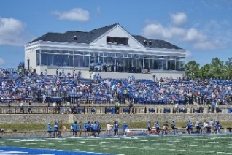
Special thanks to Dr. Doug Searcy and Beth Searcy allowing Omicron to meet in the Barton College President’s Box on November 8, 2021. Dr. Searcy shared with us how his family’s involvement with his hometown football program made his college education possible. Coach Hester discussed his vision of Barton’s football program and gave us a snapshot of his players’ schedules. Omicron members also welcomed special NC DKG guests: Beth Winstead (NC DKG State President), Anne Briley (Beth’s mom and a past Executive Secretary for Eta State), and Edie Snider (Region II Director). President Winstead encouraged Omicron members to grow their leadership skills by becoming DKG officers and committee chairs at both the chapter and state levels. She also encouraged us to attend the NC DKG State Convention and possibly assist as volunteers. Director Snider thanked us for being and remaining DKG members.

At our November meeting we collected items/gift cards for Wilson’s Veterans Residential Services. Thank you for being so generous!

On Veterans Day (11/11/2021) I had the pleasure of attending Gamma Zeta’s chapter meeting. The meeting was held in the Carteret County College’s new Culinary School located in Morehead City. The CCC President, Dr. Tracy Mancini, who is also a Gamma Zeta member, served as the program speaker and tour guide of the new facility. I value the relationship between our two chapters.

Omicron is in the last few months of its 2020-2022 biennium. The present Omicron officers served its members for the last two consecutive bienniums and the time has come for new leadership. DKG bylaws state: “No officer, except the treasurer, may serve in the same office longer than two terms in succession.”. These officers are president (or co-presidents), vice-president, secretary, and treasurer. Please say “YES” and be the spark Omicron needs and deserves. Rest assured you will not be alone, but will have the support and assistance of all Omicron members. We need YOU!
L*E*A*D*E*R*S*H*I*P

2021 – 2023 NC DKG Theme
Respectfully,
Marsha Irvin
Omicron President/Treasurer
Meetings/Programs for 2021-2022
The Executive Board has planned interesting programs for the 2021-22 year. Please mark your calendars and plan to attend our meetings, enjoy the programs, and share in our friendship and fellowship.

Date | Time | Location | Program
Monday, September 27 | 7:00 pm | Eagles Center  (Wilson Community College) | Dot Carter – “Remembering Eta State (NCDKG) Past”
Monday, November 8 | 4:30 pm | President’s Box (Barton College football field) | Coach Chip Hester
Tuesday, February 8 | 4:30 pm | St. Timothy’s Episcopal Church | Police Chief Scott Biddle
Tuesday, May 10 | 4:30 pm | Wilson Arts Council | Cathy Hardison

The information for our February meeting is shown above. Masks and social distancing are required. Let me know if you wish to attend virtually.
Opportunities
From Dot Carter – NC DKG Educational Foundation
Need funds for a classroom or educational project or for professional development? Want to honor the classroom teachers or other educators for their heroic efforts in the past year to continue to educate students? Then the North Carolina Delta Kappa Gamma Educational Foundation (NCDKGEF) presents opportunities for you!

Projects – NCDKGEF offers grants from $500 to $1,000 to fund projects that enhance education in school or community and/or to provide some funding for attending professional conferences. Go to the NCDKGEF website; see Grants tab for a listing and descriptions of the grants available. Deadline for this round of grants is January 31, 2022.

The Gray Scholarships are available again this year. Five $3,000 scholarships will be awarded to students in Music Education or Elementary Education. Deadline for the scholarship applications is March 15, 2022. Information about the scholarships is on the Foundation website. Spread the word.

From Carol Putney – Omicron’s “Love Offering”
Good news! We will not need to collect funds for our 3rd year teachers’ “Love Offering” this year. Thanks to your generous contributions the last several years, we have enough money to purchase the $10.00 Wal-Mart gift cards for our elementary teachers. Last year we recognized the middle and high school teachers. Many thanks for your continued support!
February

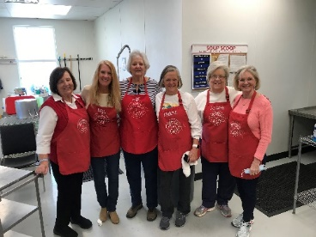
Community Soup Kitchen Volunteers
Omicron’s next scheduled Soup Kitchen date is Monday, January 31. An email will be sent to those who expressed an interest in volunteering. If you did not sign up and would like to volunteer, please contact either Martha Wrenn or Marsha Irvin. Please mark your calendars and plan to join us.

Regional Directors Needed – Tammy Cullom
If you are a past chapter president and are ready to continue in a NC DKG leadership role, please consider being a regional director. For more information, contact Edie Snider or Tammy Cullom.
From Joan Satterly – Member News
A sympathy card was sent to Christine Gilmore whose father-in-law passed away before Thanksgiving.
If you have news of members, please contact Joan Satterly, Marsha Irvin, or phone either of us.

DKG Gallery of Fine Arts
Are you an artist? A photographer? A writer? A musician? Omicron would like one or more of its members showcased in the DKG Gallery of Fine arts. The submission periods are August 15 – September 15 and January 15 – February 15. Please consider sharing your talents!

From Jerri Moore – Omicron Website
Visit http://wilsonomicron.weebly.com/ for all the latest Omicron news. Jerri has our site updated to include meeting dates/times/locations, newsletters, tributes, and photos.

Resources Tab on DKG Website Has Wealth of Information
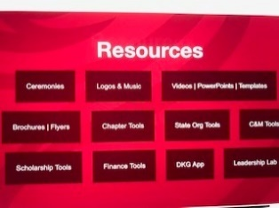
As chapters prepare programs, invite new members, update resources, or need tools of any kind, the Resources tab of the DKG website is a good place to start. It is a member’s go-to resource for anything DKG! It has music, logos, sample brochures and flyers, the ceremonies’ scripts, and tools for communication and marketing, scholarship, finance, and general chapter tools, such as a new member kit, chapter strengthening tips, best chapter projects list, and fundraising ideas. Become familiar with what is there so that when you or your chapter needs ideas, support, or tools, you know right where to go! (Log in to have access to it.)

Omicron newsletter

Please let Marsha know if you have any announcements, suggestions, articles, etc. for our newsletter. You may call/text Marsha at 252-230-3830 or email her at Marsha Irvin.

Online DKG News
The 2022 January/February issue of DKG News is available online-only on the DKG website. Have you set up an account on the DKG website? All you need is your membership ID number which is printed on your DKG membership card. Go to http://www.dkg.org and set up your account!

The Winter 2021 issue of NC DKG News is available online. Go to https://www.ncdkg.org/ to read the exciting things happening in NC DKG chapters. NC DKG members and chapters are encouraged to send information to be used in the NC DKG News to Carol Bostian, Editor. Newsletter Deadlines to submit information are August 1(Fall), November 1 (Winter), February 1 (Spring), and May 1 (Summer).

2022 NC DKG Convention
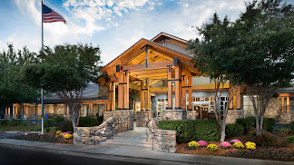
When/Where: April 29 - May 1, 2022 in Asheville’s Crowne Plaza Resort.
Registration: Registration is now open. To register, use the Google form found on https://www.ncdkg.org (click on 2022 NC DKG Convention Information”). Early bird registration is open until April 10 and is $35/person. After April 10, registration is $45.

Hotel Reservations: We have a group rate of $155 + 13% tax per night on a room with two queen beds. You may call 1-844-330-0296 to reserve your room. When you call, state you are part of the Eta State Delta Kappa Gamma to receive this special rate. You can also go to the hotel’s website www.ashevillecp.com and enter code ETA.

Speaker: International President Rebecca Sandowski
Convention Project: MANNA FoodBank located in Asheville and distributes more than 50,000 pounds of food daily to food pantries/organizations. You can donate even if you are not able to attend the convention. You can donate online by visiting the MANNA FoodBank’s website or send your donation to MANNA FoodBank, 627 Swannanoa River Road, Asheville, NC 28805.

Tours Available: Penland School, Blue Ridge Parkway, and Carl Sandburg Home

Volunteers needed: Once registered, if you wish to serve as a volunteer, click Volunteer form
or contact Convention Chair Connie Savell.

Need more information? Go to the NC DKG website and click on the “2022 NC DKG Convention Information” link.

Make Plans to attend the 2022 NC DKG Convention in Asheville, NC!

-------------------------------------------------------------------------------------------------------------------------------

Important Dates for Omicron Members
January 15 – February 15, 2022 Arts & Humanities Gallery Submission
January 25, 2022 Deadline to apply to present at the NC DKG Asheville convention
January 31, 2022 NC DKG Educational Foundation Grants application due
February 1, 2022 Scholarship applications due for NC DKG and DKG International
March 1, 2022 DKGIEF Project applications due
March 15, 2022 Deadline for vendor and ad forms for the convention
April 1, 2022 Deadline for postmarks for mailed convention registration
April 10, 2022 Deadline for Early Bird Registration for 2022 convention
April 29-May1, 2022 NC DKG Convention, Crowne Plaza Resort (Asheville NC)
July 12-16, 2022 International Convention, New Orleans, LA
April 28-30, 2023 NC DKG Convention, Greenville, NC (next year)

2021 – 2023 NC DKG officers
Beth Winstead President
Hilda Parler First Vice President
Tammy Cullom Second Vice President
Patty Higgins Secretary

Omicron Officers For 2021 – 2022:
President Marsha Irvin
Vice-President Tasha Weatherington
Recording Secretary Jean Yelverton
Corresponding Secretary Joan Satterly
Parliamentarian Rosalie Bissette
Treasurer/Editor Marsha Irvin
Past President Marsha Irvin

Committee Chairs for 2021-2022:
Educational Excellence Committee Catharine Reed
Membership Christine Gilmore
Scholarship Pat Campbell
Nominations Beverly Boyette / Isabel Fulghum
Rules Dot Carter
Communications Dana Skinner
Publicity Mamie Boyette
Finance
Strategic Action Plan…………………Dot Carter
Westview House Project Pat Campbell

International Website: https://www.dkg.org

NC DKG Website: www.ncdkg.org

Omicron Website: http://wilsonomicron.weebly.com

Region II Director: Edie Snider

-------------------------------------------------------------------------------------------------------------------------------

